Uploading your work file on SharePoint
Step 1
Make sure that your Work File archive is completed, and you have already sorted all documents in the suggested folders.
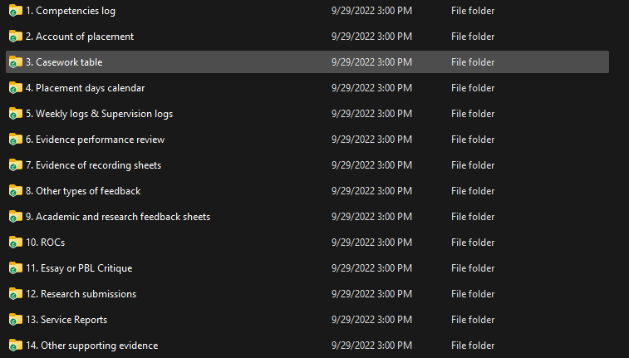
In the screenshot above you can see the folders sorted on a local machine (e.g., your laptop).
At this stage, if you proceed to create your hyperlinks on the BPS Competency Log it essentially means you are creating a link to a file that is on a local machine.
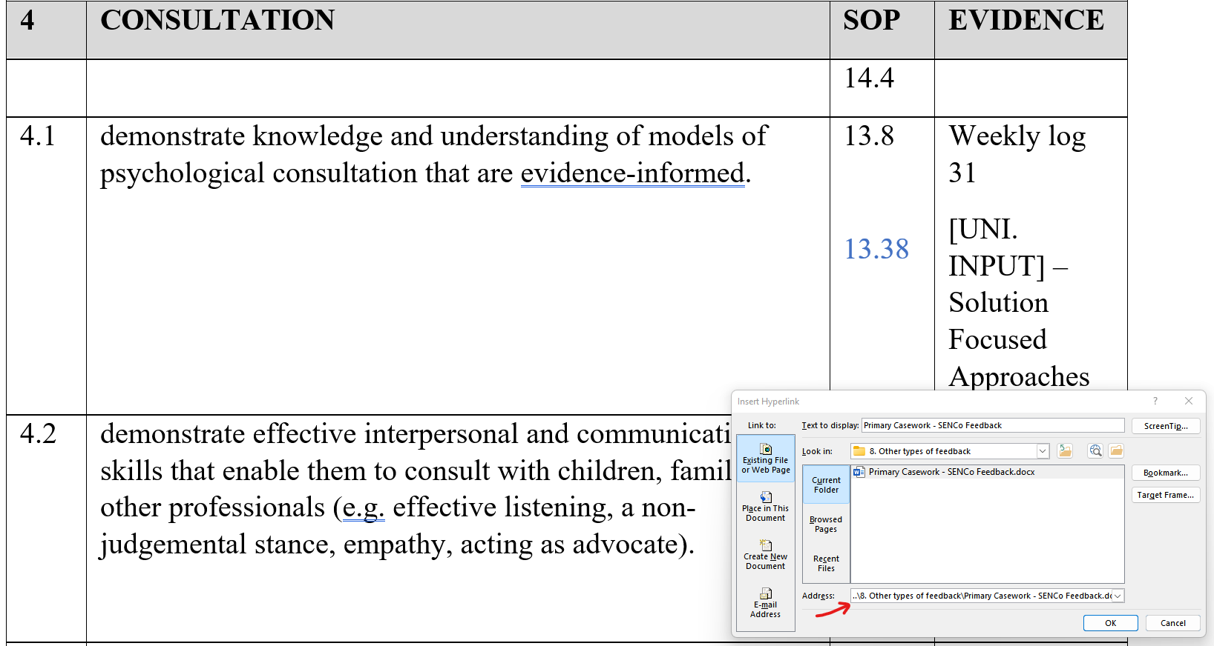
Note in the address box you can see that the link takes the user (e.g., your work file marker) to the document as intended, however the user needs to have access to your local machine to open the file. As such, the user will not be able to access the file.

Step 2
You should have received a link via email from the course’s admin that takes you to your personal folder on the University’s SharePoint which is the online cloud system used by the course.
Click on the link and open the folder that has your name on it. It might be the case that the link directly takes you in the folder with your name on it so no need to click on anything.
At this stage, select all files in your Work File on your local machine,
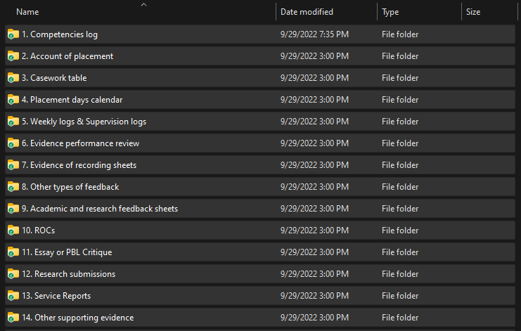
then drag and drop all the files in the SharePoint folder on your web browser.
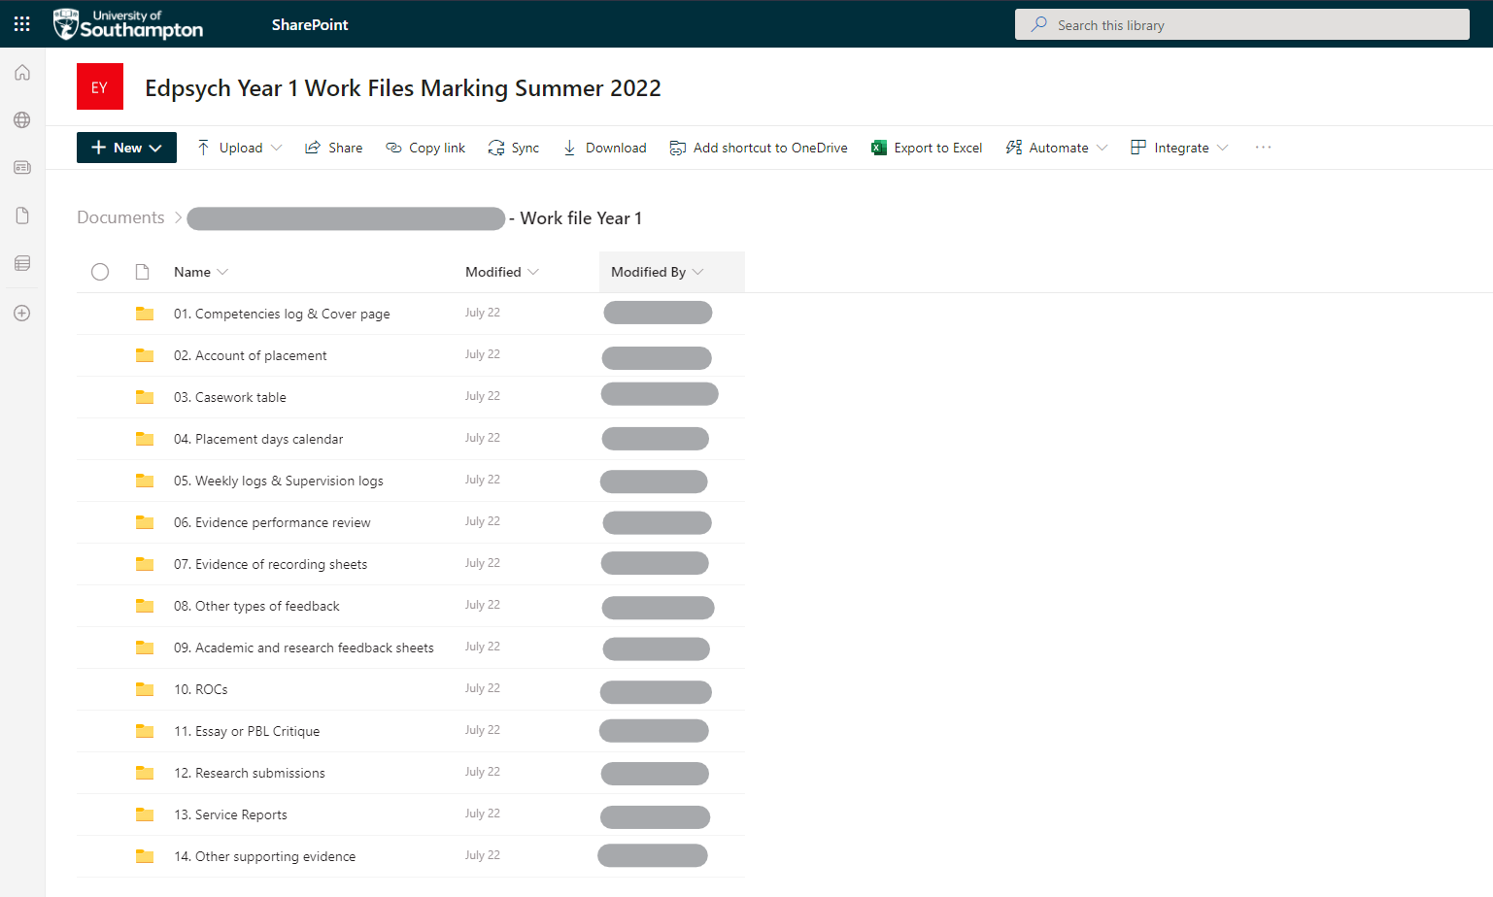
Alternatively, instead of using the drag and drop method, you can click on the “Upload” option on the top left corner of your screen on SharePoint.
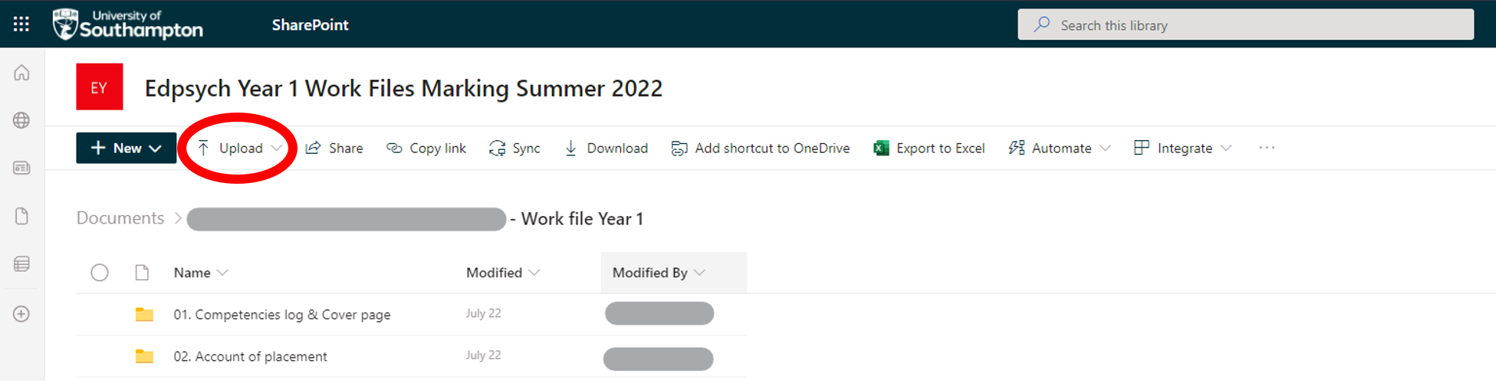
Then select “Folder”,
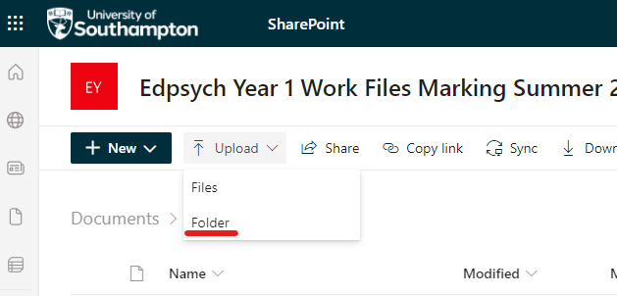
and proceed to select the folder you need and click on “Upload” on the bottom right of your screen
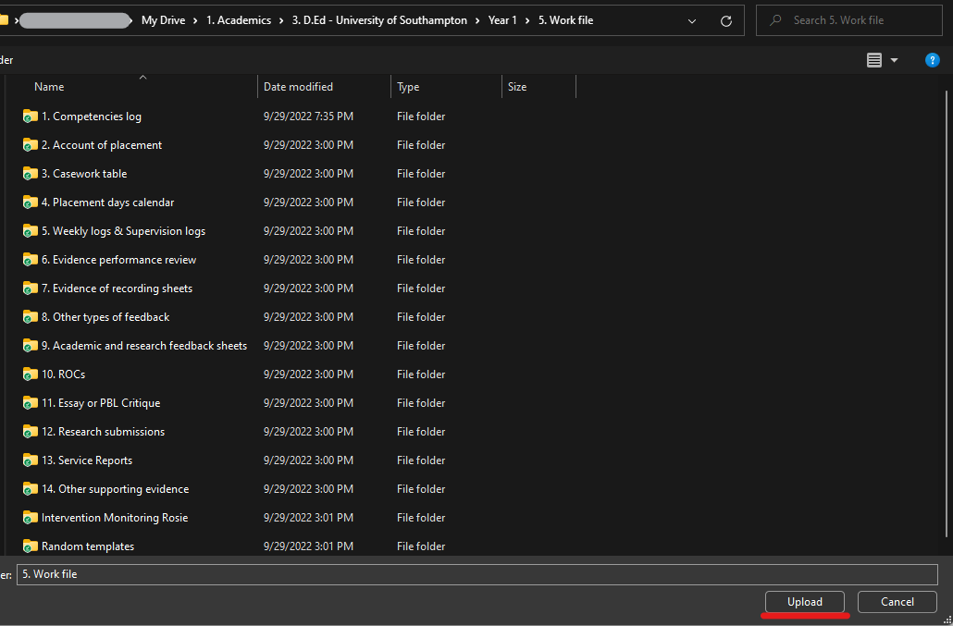

Step 3
You can now proceed to create the hyperlinks.
Open the “Competency log” folder in your Work File on SharePoint.
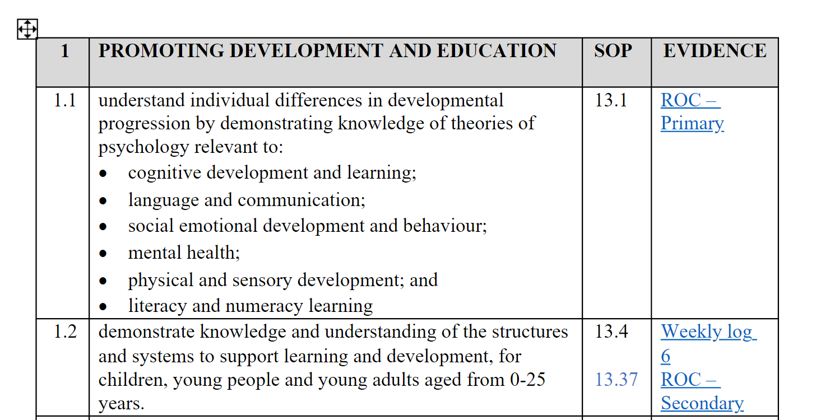
In this example, I want to create a hyperlink for the ROC-Primary. For this, I will locate my ROC-Primary file
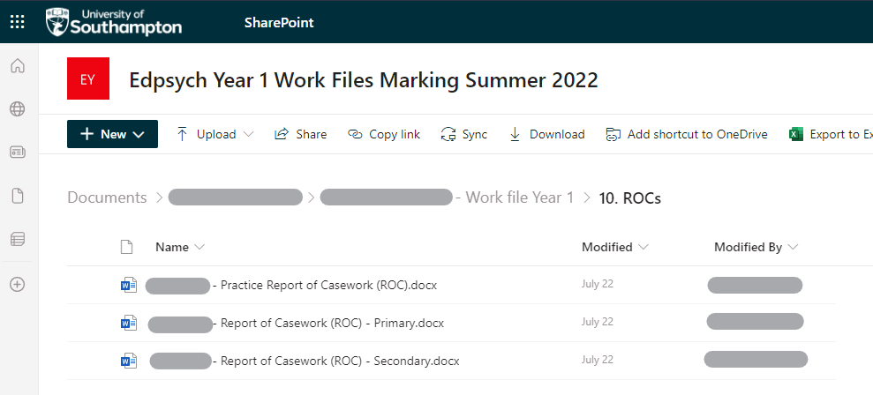
then right click and select “Copy link”.
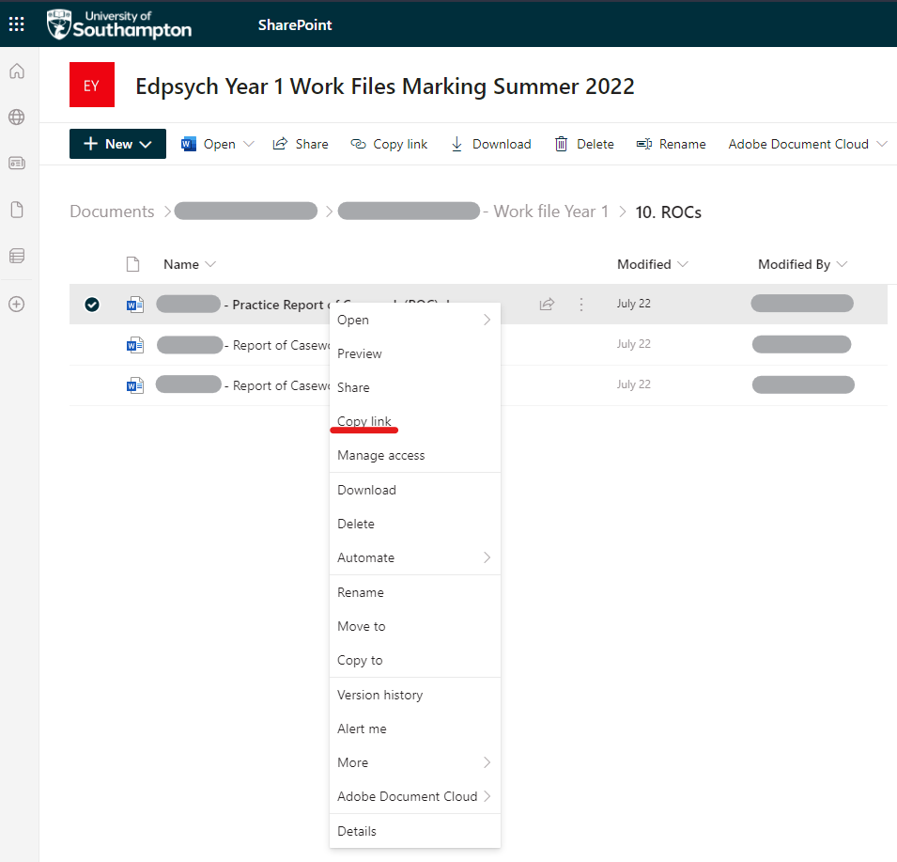

Click “Copy”
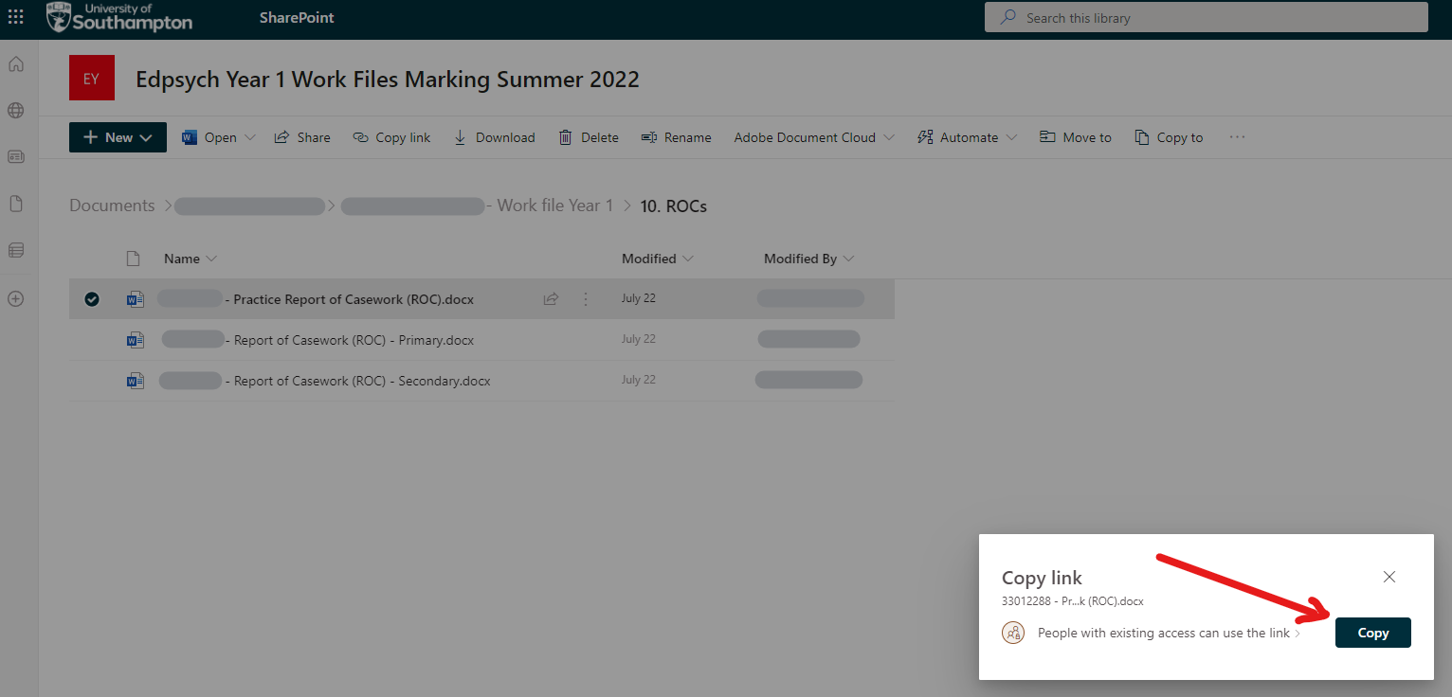
Then you should see the pop-up below confirming that you have copied the link.
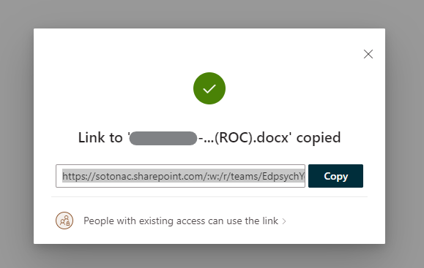
Now go back to your Competency log and right click on “ROC-Primary” and select “Link” and “Insert Link”
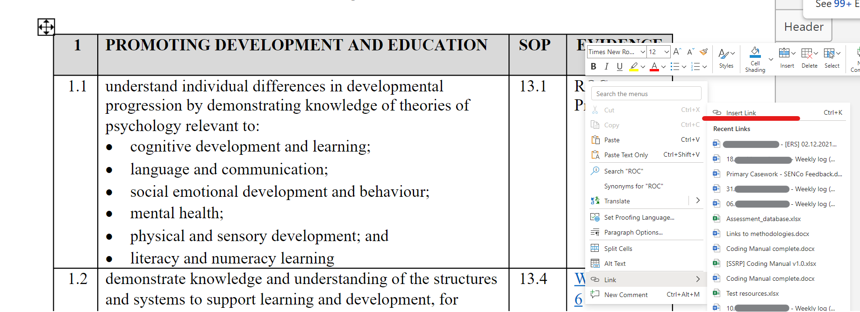
then paste the link in the bottom text box and click insert.
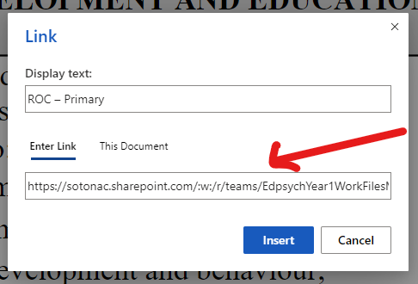
As you can see, the address to the document starts with https://sotonac.sharepoint.com. This indicates that the address you have provided links to a file that is on SharePoint and not on your local machine. Proceed to test the link by clicking on “ROC-Primary” (or your file name) and you are done!

