CBT Centre: Guidelines for video recording and submissions

Our CBT programmes involve clinical practice that is assessed both formatively (to give you feedback on your progress) and summatively (to determine whether you have met the required level of competency). Supervisors assess your formative video recordings halfway through each supervision module, and our extended team of programme staff assesses your summative video recordings at the end of each supervision module. Additionally, you will bring illustrative clips of therapy to every supervision session. This guide is to help you set up your equipment, encrypt your recordings, and upload these for supervision and assessment.

How do I seek consent to record?
You are required to obtain signed consent from your patient to record therapy sessions and use these for supervision and assignment purposes. It is your responsibility to ascertain whether your Trust or organisation requires use of a standard consent form. If not, and for those working independently, you will use the template available in the CBT handbook and on Blackboard.

Duration and quality of recordings
Your full session submissions should be a maximum of 60 minutes (unless conducting imaginal reliving for PTSD or video feedback for social anxiety which can be up to 90 minutes long). Your video file should be no larger than 2GB. For weekly supervision sessions, you will need to prepare an excerpt which will usually be related to your supervision question, and have this ready to be played. You are responsible for checking both sound and visual quality prior to use or submission. Sound quality depends on a number of variables including quality of recording device and microphone, external noise and equipment set up. If you use a laptop for recording, the following set up should maximise sound quality. Please note that this diagram is intended to help you set up for face-to-face interviews. Please ignore if recording interviews via Teams or Zoom.

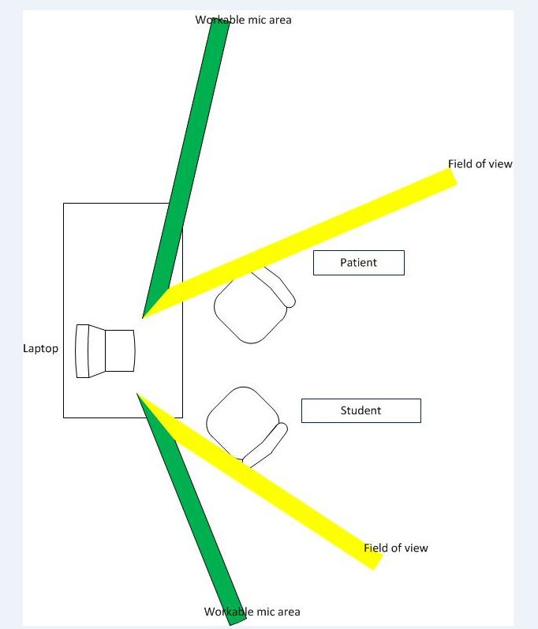

The diagram above shows the optimum arrangement of the recording environment. The area to the right of the green lines is the workable area of the built-in microphone on your laptop. If a client is sat to the left of these lines, or behind the laptop, you will not record their voice with any clarity. Also, be aware of any background noise from open windows etc. Your laptop should be sat on a hard surface such as a table, and not on anything soft which will absorb sound and muffle the recording. The yellow lines approximate the field-of-view of the camera, so if your client is outside these lines you should not record their face. Check this prior to commencing your interview.

Which therapy sessions should I submit?
Your full session video submissions relate to the two cases you discuss in university supervision for each supervision module. For summative assignments, you will be in the change phase of therapy, and are likely to have completed at least five therapy sessions.

How do I save and upload recordings?
Important note: this can be a complex and time-consuming task so please read and adhere to this guidance to ensure you meet security requirements and avoid late submission penalties
Recordings must be clearly named using the following format: “YourUoSStudentNumber_DDMMYY of recording_ModuleNumber” e.g. 20514091_10.10.19_PSYC6095.

It is essential that you name (or rename) your recording in this way BEFORE you encrypt.
All video files need to be encrypted before submission. This is essential for Information Technology Governance (ITG) and Data Protection reasons. It is your responsibility to follow your Trust or organisation encryption and security requirements. Most students use McAfee File, Removable Media Protection or 7Zip protection software.
When encrypted, upload your recording to the University of Southampton ‘SafeSend’ (previously ‘Dropoff’) service. This can be accessed via https://safesend.soton.ac.uk/ using your university username and password, and following the instructions. If your internet access is poor or your file is large, this can be slow. If your recording has not successfully uploaded, you will need to repeat this process. It is your responsibility to ensure that this is done before the assignment deadline. You are strongly advised to complete this process well ahead of the deadline to avoid late penalties which are automatically applied.
Formative recordings: upload these to your University supervisor by entering their email address in the required field.
Summative recordings: upload these to cbtadmin@soton.ac.uk for distribution to the assignment markers.

What paperwork do I need to submit with my recording?
Your supervisor or university assessor requires some context to the full session therapy recording. You will therefore provide the following with each submission:
1. Assignment front sheet (in e-handbook) – for summative assignments only
2. Self-rating using the CTS-R – including scores, consent obtained and comments
3. Formulation diagram, constructed collaboratively with your patient
4. Brief overview of the session (200 words max) including brief biographical information; presenting problems on which you are focusing; therapy goals jointly agreed; session number; aims for the current session
5. Patient scores on standardised measure at baseline assessment and at the time of current session (where known), and a brief statement on how you have incorporated this information in your clinical decision making
6. A reflective analysis of the session (500 words max) discussing the case and linking this to your session content, highlighting points of good practice, areas for improvement and key learning
7. Signed and dated statement that this session has not been submitted previously
Formative recordings: provide the combined document directly to your University supervisor by session five of your supervision module
Summative recordings: upload the above as a single word document to efolio
Recordings submitted without all the necessary paperwork will be deemed an incomplete submission, and may result in failure.

Trial submission – formative assignment
In addition to the formative and summative full therapy submissions, you will be required to submit a five-minute clip of two people talking, prior to your first full therapy submission. The purpose is to confirm that you fully understand the entire recording and submission process, and linked security issues. Please ensure that you name (as per instructions above, putting ‘trial’ in place of the Module number) and encrypt your recording before uploading. For the trial submission ONLY, please send your files to Paul Reynolds pr1a08@soton.ac.uk who will check that they are in the correct format and offer advice if you encounter any difficulties.

Privacy Impact Statements
The University of Southampton has agreed / is working towards Privacy Impact Statements with local NHS Trusts (Southern Health, Dorset Healthcare, Isle of Wight, Avon & Wiltshire, Solent, and Berkshire Healthcare) to satisfy confidentiality and Caldicott requirements.

Confirmation
I have read the above guidance for video recording and submissions (version 5) and am aware of my responsibilities (and employing Trust / organisation where applicable) for ensuring the security of recordings.

Signed: _____________________________________________
Name (student): ______________________________________ Date: ________________________

Signed: _____________________________________________
Name (manager / supervisor): ___________________________ Date: ________________________
Designation: _________________________________________

Appendix 1: Uploading videos to SafeSend

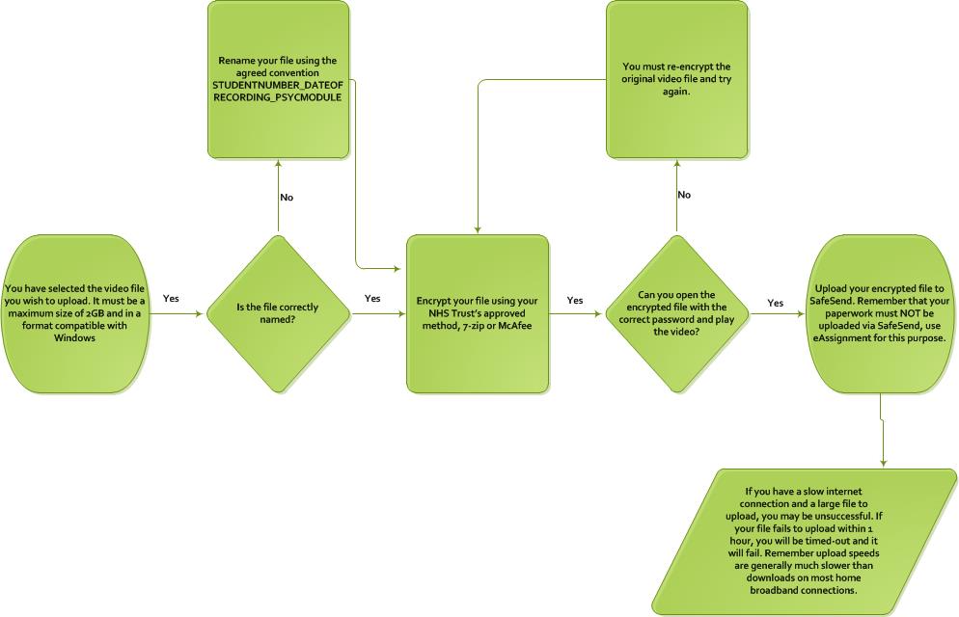

Appendix 2: Useful tip for 7-zip users
To save time and make life easier (which is always good!) rather than opening your 7-zip software to encrypt a file, follow these two steps once you have selected the file you wish to encrypt. Please note, this only works for 7-zip so McAfee users (e.g. Southern Health students) will not benefit from this suggestion!

1. Select the file you wish to encrypt and right-click on it. Hover over 7-zip and then click ‘Add to Archive’
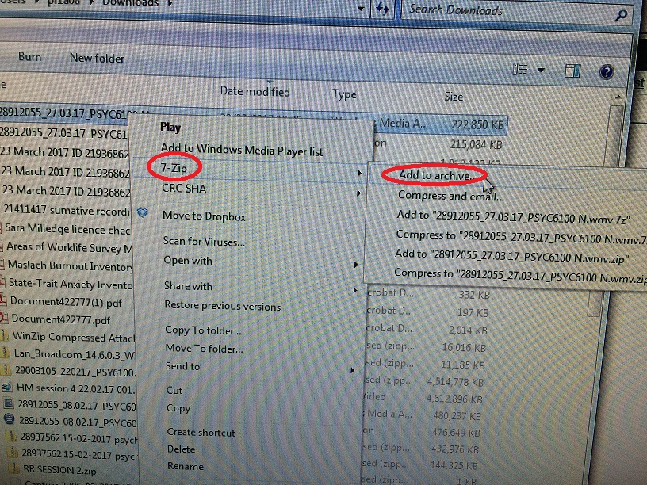

2. This will open 7-zip for you. Simply enter the agreed password (I recommend ticking the ‘Show Password’ box so you can check it’s entered correctly) and click OK. The encryption will then start with no further input required.
